**7.1.3**

**Swach Bharath:**

**Swach Bharath mission, Swach Bharath Abhiyaan or clean India Mission is a country wide campaign initiated by the Government of India in 2014 to eliminate open defecation and improve solid waste management. It is a restructured version of the Nirmal Bharath Abhiyaan launched in 2009 carried through by successor Manmohan Singh that failed to achieve its intended targets.**

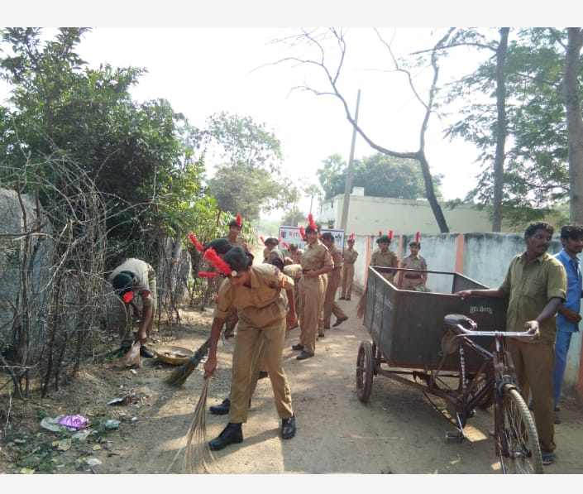

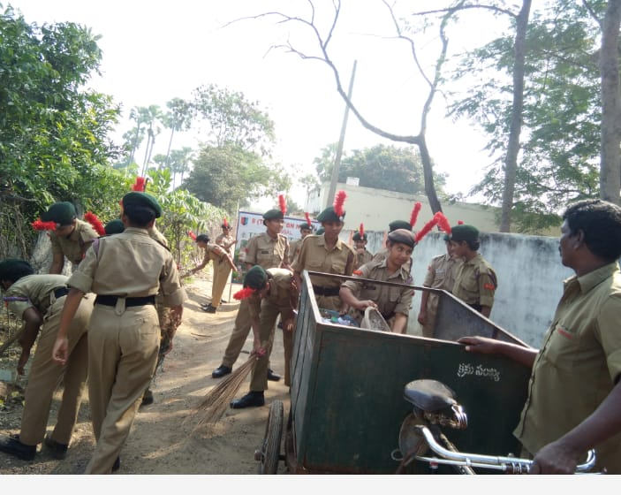

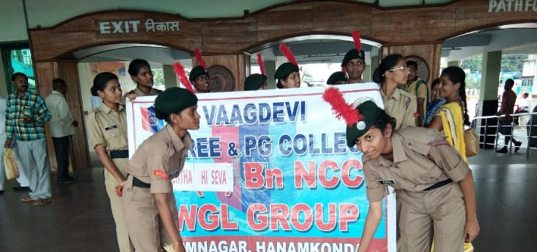

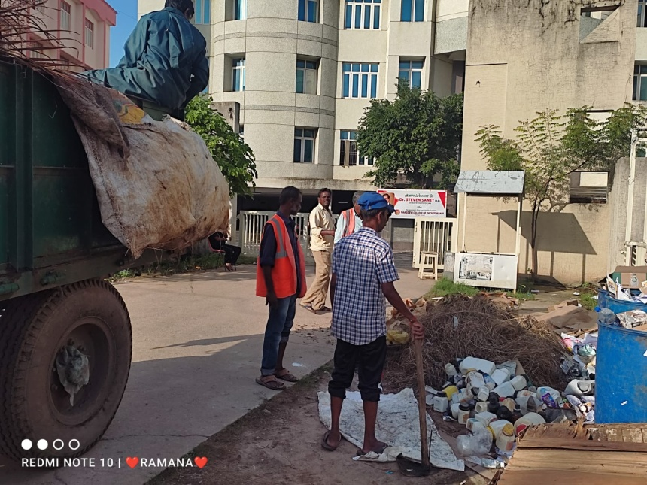

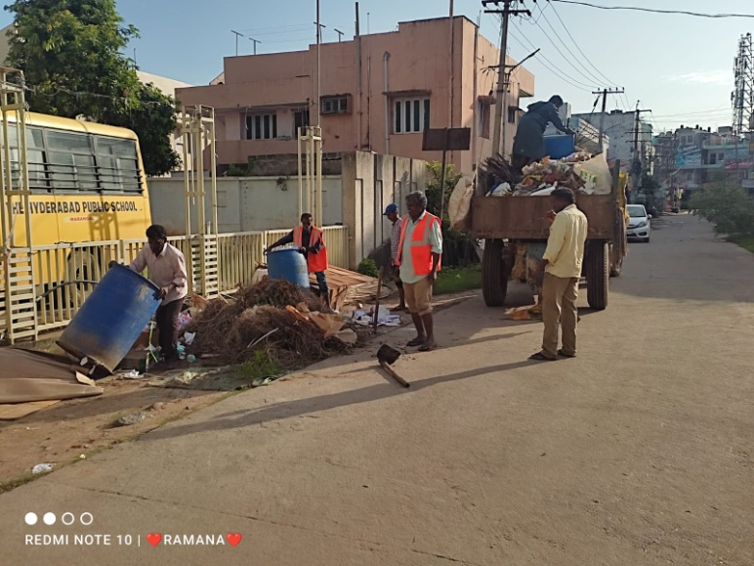

**Collection of waste in the campus**

**Haritha Haaraam**

**For Telengana Haritha Haaram is a large scale replantation program implemented by the Government of Telengana to increase the amount of tree cover in the state from 24% to 33%. Specific duties and responsibilities are assigned to ensure implementation in a well designed manner. They regularly monitor the ongoing plantations and nursery workers.** 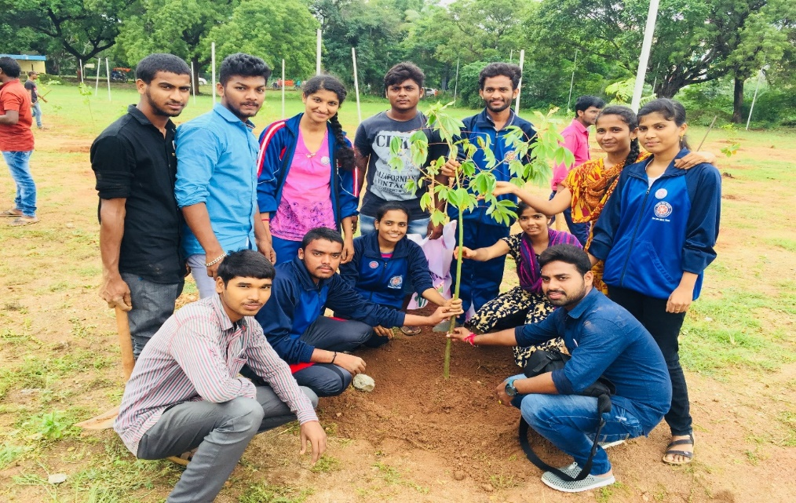

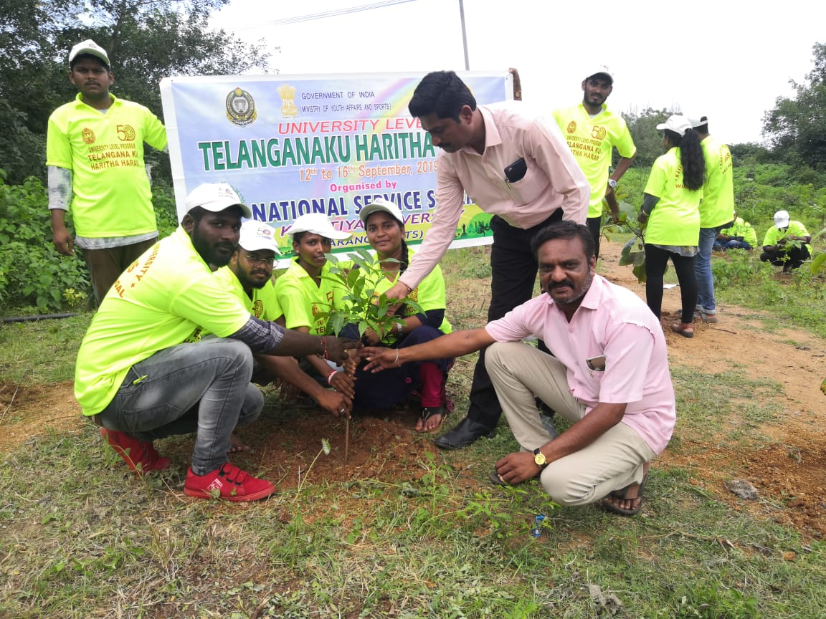

**Jal shakthiAbhiyaan**

**It was started to develop us a knowledge centre to disseminate all information regarding water. It includes importance of water harvesting which is required for saving water and helping in raising the water table.**

